Brno to become the host of the ICRI 2022 conference

The Czech Republic has become the host of the ICRI 2022 conference (International Conference on Research Infrastructures), a worldwide conference dedicated to research infrastructures. ICRI 2022 will visit Brno on the occasion of the upcoming Czech Presidency in the EU Council in the 2nd half of 2022, and will provide a platform for high-level debates of research infrastructure policy-makers, operators and users, and research stakeholders from Europe, America, Asia, Africa and Australia to address the most pressing research infrastructure topics. The conference will be held under the auspices of the Ministry of Education, Youth and Sports of the Czech Republic, the Masaryk University and the Central European Institute of Technology in Brno. The organisers will closely collaborate with the European Commission’s Directorate-General for Research and Innovation, which will financially contribute to the organisation of the event via the 9th EU Framework Programme for Research and Innovation Horizon Europe.
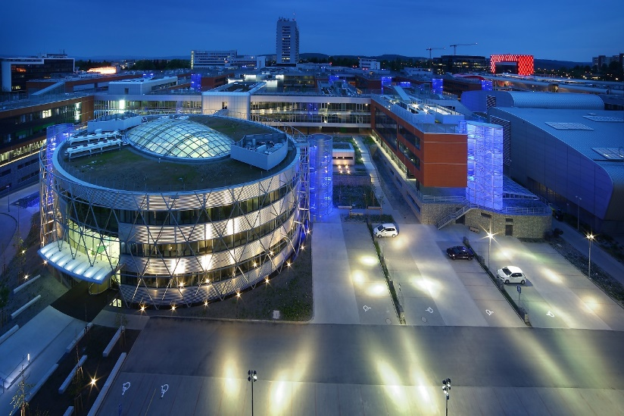
Central European Institute of Technology in Brno (CEITEC) – Masaryk University

Benefits of research infrastructures to socioeconomic development
The ICRI 2022 key themes will be the mobilisation of research infrastructures in response to the Covid-19 pandemic, the role of research infrastructures in the Covid-19 post-pandemic recovery, as well as strengthening the resilience and preparedness of the worldwide society to respond to any future crisis scenarios and crisis events. At the same time, the conference will focus on the benefits of investing in research infrastructures for the (macro-) regional development. In addition to that, the conference will be aimed on a broad range of other research infrastructure issues, such as the role of smaller national research infrastructure facilities next to large-scale international laboratories and their international cooperation, or the development of international data infrastructure, enabling the sharing of scientific data across research institutions and scientific disciplines according to the FAIR principles (Findability, Accessibility, Interoperability, Reusability). The ICRI 2022 programme will combine plenary and parallel (break-out) sessions with over 500 attendees from all around the world participating.

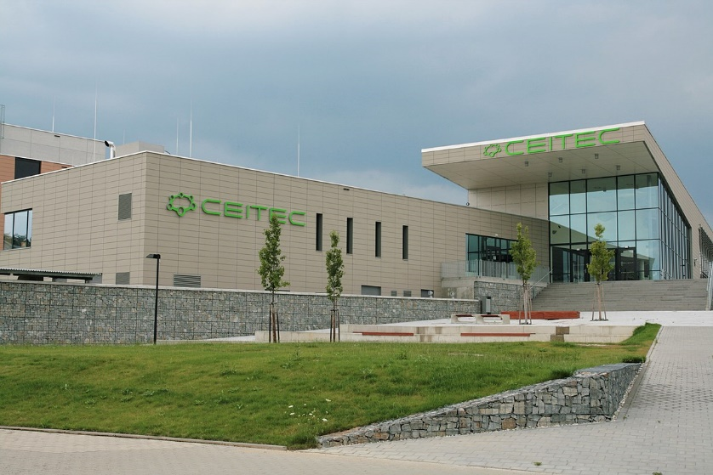
Central European Institute of Technology in Brno (CEITEC) – Brno University of Technology

Brno to become the venue of the ICRI 2022 conference
ICRI 2022 will build on the previous conferences held in Copenhagen (2012), Athens (2014), Cape Town (2016), Vienna (2018) and Ottawa (2021).

As the host of the conference, Brno will become a worldwide centre for research infrastructure stakeholders’ debates in the week from 17th to 21st October 2022.

As a back-to-back event, a meeting of the European Strategy Forum on Research Infrastructures (ESFRI) will take place in Brno in the same week, while a number of “satellite events” can also be expected on the margins of the ICRI 2022 conference, accompanying the main event. Last but not least, participants of ICRI 2022 will have the opportunity to visit research infrastructures located in Brno and operated by local universities and research institutes, and thus get to know Brno as one of the emerging centres of science and technology in Central Europe.

Video-invitation for the ICRI 2022 conference

