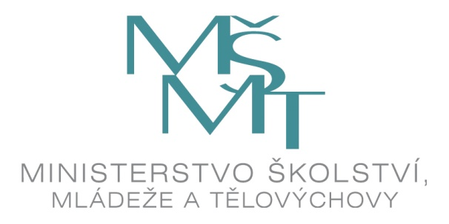

SCHOLARSHIP APPLICATION FORM

Please type or complete in block letters and submit in duplicate.

Academic year | 202 – 202 | Photo (optional)
Length of visit
(in months)
Period | from to

APPLICANT DATA
Family name |  | First name(s)
Academic Degree(s) and Rank(s)
Gender |  | Date of birth (dd/mm/yyyy)
Citizenship |  | International passport / ID card No., as applicable  (not required of citizens of EU/EEA countries)
E-mail |  | Telephone (in international format)

Permanent residence address | Street, number | City, zip code | Country

Complete mailing address (if different from above) | Street, number, etc. | City, zip code | Country

Optional:
Person to be notified in case of emergency: name, surname, address, phone, e-mail (the extent of data provision at the discretion of the applicant)
CURRENT EMPLOYMENT
Name and address of employer
Present occupation

EDUCATIONAL BACKGROUND
Highest academic degree awarded
Field / specialiation

Language proficiency
Languages | Skills – please indicate the appropriate level using a scale ranging from 1 (beginner) to 6 (near native speaker level).
 | Listening | Reading | Speaking | Writing
Czech
English
French
German
............
............

PLANNED RESEARCH IN THE CZECH REPUBLIC
Name of the host institution, faculty
Field of research
Working language | Czech  English  German  French
Have you obtained a letter of invitation from the host institution? | YES (please attach a copy)  NO
The main objective of your research stay in the Czech Republic
Have you been a scholarship-holder in the Czech Republic during the past three years? If so, please specify.
Do you wish to be accommodated at a student dormitory? | YES  NO

I ATTACH THE FOLLOWING DOCUMENTS:
Academic CV  Detailed plan of research  List of publications | Passport/ ID copy  Letter of invitation
All documents must be submitted in duplicate and written in or translated into Czech or English.

Nota bene:

- Incomplete scholarship application dossiers and/or inadequately completed scholarship application forms will not be processed.

- The Ministry of Education, Youth and Sports (MEYS) reserves the right to change the requested term of scholarship and/or place any applicant to a course and/or higher education institution different from those indicated in his/her scholarship application form, if the admission as required by the applicant is not possible.

I have been informed of the terms of the scholarship.

I hereby certify that the information given in this application is true and complete to the best of my knowledge.

By filing this application for the MEYS scholarship, I hereby acknowledge that my personal data provided in the application form and attachments thereto submitted for the purpose of selection proceedings as well as for the purpose of my possible later nomination will be processed by the respective diplomatic mission of the Czech Republic, by the Ministry of Education, Youth and Sports of the Czech Republic, by the Czech National Agency for Education and Research and by the appropriate host university or universities in the Czech Republic, to the extent that is necessary to address my application, in compliance with the Regulation (EU) 2016/679 of the European Parliament and of the Council of 27 April 2016 on the protection of natural persons with regard to the processing of personal data and on the free movement of such data, and repealing Directive 95/46/EC (General Data Protection Regulation). I also hereby acknowledge the fact that my aforementioned personal data will be forwarded to other state authorities in the Czech Republic provided that it is necessary for the processing of my scholarship application, and information on the outcome of my application will be conveyed to the respective nominating agency, i.e. to the appropriate diplomatic mission of the Czech Republic or the respective authority of the foreign state concerned. I also acknowledge that my personal data will be stored in analogue documents as well as in digital form by the Ministry of Education, Youth and Sports of the Czech Republic and by the Czech National Agency for International Education and Research for the period of 10 years in their archives, in compliance with their respective File Retention and File Destruction Rules.

Place ……………………… | Date…………………… | Handwritten signature…………………………………………

